**Using the handout on persuasion and the annotated copy of ‘Saving Ningaloo Again’ (on SEQTA), answer the following questions.**

1. **Explain how Tim Winton structures this text to create persuasive, logical reasoning to position the audience to support his viewpoint. You’ll need to write at least two fully developed paragraphs.**

**Winton uses the persuasive structures of appearance vs reality and ubiquity to create persuasive, logical reasoning to position he audience to support his viewpoint on anthropogenic activity. Winton contrasts the appearance vs reality by showing that despite the general public believing Ningaloo is safe and preserved, the text outlines that it’s in danger of destruction. Winton uses a cumulation of verbs of “lang-clearing”, “scouring”, “dredging” and “dragging”. These words have negative connotations, hence connecting Ningaloo with negativity, thus positioning the audience to support his viewpoint. This shows that Ningaloo is not safe.**

**Winton also uses a list of 3, each listing being an unwanted effect of carbon dioxide emissions, when he writes “heating the ocean, turning them acid, killing coral”. This emphasizes the effects of anthropogenic activity on the ocean, hence positioning the audience to support his viewpoint. Winton also uses emotive language when he writes “Some Australians will be surprised to learn how…” and “Many more would be shocked to see…”. This has the effect of outlining the appearance vs reality of Ningaloo, hence positioning the audience to support his viewpoint.**

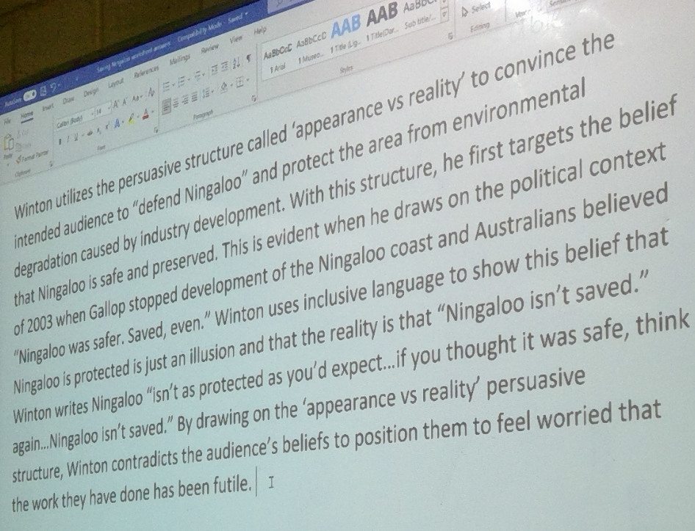

1. **Explain how Tim Winton influences the audience to take a side on a controversial issue by appealing to the emotions and values of the intended audience. You’ll need to write at least two fully developed paragraphs.**

**Winton influences the audience to take a side on the issue of anthropogenic activity by appealing to the emotions and values of the intended audience. Winton appeals to the values of the intended audience through the title by making it appeal to the value of protection of the environment. The title “Western Australia’s World Heritage site isn’t as protected as you’d expect” shows that the author values the environment, appealing to the emotions and values of the intended audience.**

**When Winton writes that Australians will defend Ningaloo “for the enduring principle of the common good against the interests of a powerful few”, this appeals to the audience’s values the outdoors, family and “a fair go”, appealing to the emotions and values of the intended audience by getting the audience to feel that the author has similar values to the audience, increasing the support for his viewpoint.**

1. **Read the annotated copy first and use this to add annotations on your own hard copy.**
2. **Read and highlight the handout on Persuasion. This explains persuasive structures and appeals.**
3. **Type your answers to question A and B. You’ll send this to me at the end of class Tuesday 4th May.**